Members:

Quinn Johnson, Hale Bradley

Run input file on CS Hadoop Cluster:

1. Navigate to proj-3 directory

1. Put local file into Hadoop server proj3 folder

1. Navigate to app directory

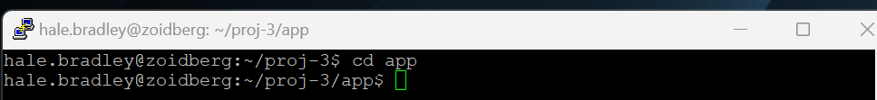

1. Run file on jar file

1. See output files in Hadoop server

Results:

1 mapper and 4 reducers